* Jab - a sudden punch.
* Cross - a straight punch.
* Hook - a short side power punch.
* Uppercut - a short swinging upward power punch.

[types of punches boxing - Bing images](https://www.bing.com/images/search?view=detailV2&ccid=KUz7mAw5&id=98EDFE17A6B6D863FEEDEC1F56F78B80F78BCC55&thid=OIP.KUz7mAw5k-k3mZWlVkp8zQAAAA&mediaurl=https%3A%2F%2Fsmartmma.com%2Fwp-content%2Fuploads%2F2020%2F08%2FBasic-Punch-Combinations-300x247.jpg&exph=247&expw=300&q=types+of+punches+boxing&simid=608043236443322812&form=IRPRST&ck=A14173F3944ADA01757041E44E4B6508&selectedindex=4&ajaxhist=0&ajaxserp=0&pivotparams=insightsToken%3Dccid_af2PvNek*cp_DB0A73B366A4EF420FAF748CA291A0A8*mid_9EB499883EFF06086B9041F35806849BEE526CB0*simid_608039469738393562*thid_OIP.af2PvNekSddl5y9e6FTJDAHaHy&vt=0&sim=11&iss=VSI&cdnurl=https%3A%2F%2Fth.bing.com%2Fth%2Fid%2FR.294cfb980c3993e9379995a5564a7ccd%3Frik%3DVcyL94CL91Yf7A%26pid%3DImgRaw%26r%3D0)

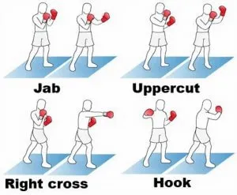

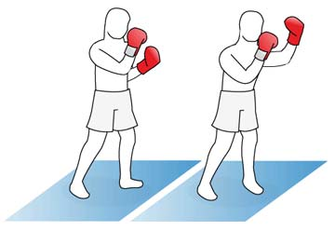 [types of punches boxing - Bing images](https://www.bing.com/images/search?view=detailV2&ccid=MtWE%2FjVn&id=0788C1ED02C496AE45D0BA220941A631A492C2E9&thid=OIP.MtWE_jVnXnY8eKk5XUYSIwAAAA&mediaurl=https%3A%2F%2Fwww.talkboxing.co.uk%2Fimages%2Fd32175%2F359_boxing-2.jpg%3F1212583707&exph=248&expw=360&q=types+of+punches+boxing&simid=608037275023256553&form=IRPRST&ck=E0EA4245B9B646AAF2179905A999B1CD&selectedindex=1&ajaxhist=0&ajaxserp=0&pivotparams=insightsToken%3Dccid_tf6hqwLO*cp_1C00BF291F0BAF62E85B35759E288CA2*mid_2868ABEEAB2A421D72D9FE279676973E049BE297*simid_608038731173821865*thid_OIP.tf6hqwLO!_UzalA!_w-CVoQAAAAA&vt=0&sim=11&iss=VSI&cdnurl=https%3A%2F%2Fth.bing.com%2Fth%2Fid%2FR.32d584fe35675e763c78a9395d461223%3Frik%3D6cKSpDGmQQkiug%26pid%3DImgRaw%26r%3D0&ajaxhist=0&ajaxserp=0)

JAB

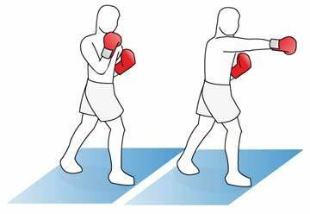 [types of punches boxing - Bing images](https://www.bing.com/images/search?view=detailV2&ccid=tf6hqwLO&id=2868ABEEAB2A421D72D9FE279676973E049BE297&thid=OIP.tf6hqwLO_UzalA_w-CVoQAAAAA&mediaurl=https%3A%2F%2Ffuhlst-gearbeitet-geschlafen.com%2Ftpvs%2FLDYCk42PgCYfaMp25GQJmQAAAA.jpg&exph=248&expw=360&q=types+of+punches+boxing&simid=608038731173821865&form=IRPRST&ck=1C00BF291F0BAF62E85B35759E288CA2&selectedindex=7&ajaxhist=0&ajaxserp=0&pivotparams=insightsToken%3Dccid_KUz7mAw5*cp_A14173F3944ADA01757041E44E4B6508*mid_98EDFE17A6B6D863FEEDEC1F56F78B80F78BCC55*simid_608043236443322812*thid_OIP.KUz7mAw5k-k3mZWlVkp8zQAAAA&vt=0&sim=11&iss=VSI&cdnurl=https%3A%2F%2Fth.bing.com%2Fth%2Fid%2FR.b5fea1ab02cefd4cda940ff0f8256840%3Frik%3Dl%252bKbBD6XdpYn%252fg%26pid%3DImgRaw%26r%3D0)

RIGHT CROSS

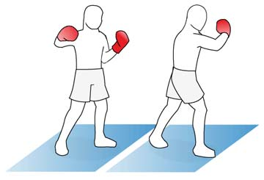 [types of punches boxing - Bing images](https://www.bing.com/images/search?view=detailV2&ccid=Pb9adTne&id=F6A75FB535E123AAB773E28ACD20C51B524A549C&thid=OIP.Pb9adTneWZ4VUbyNT6qKywAAAA&mediaurl=https%3A%2F%2Fth.bing.com%2Fth%2Fid%2FR.3dbf5a7539de599e1551bc8d4faa8acb%3Frik%3DnFRKUhvFIM2K4g%26riu%3Dhttp%253a%252f%252fcf.fitnessista.com%252fwp-content%252fuploads%252f2012%252f08%252f423_hook-2.jpg%26ehk%3DhtGURRz1gzzvSkOSk6GjIXwMO0tBiXF8m76Y3nI97Ls%253d%26risl%3D%26pid%3DImgRaw%26r%3D0&exph=245&expw=360&q=types+of+punches+boxing&simid=607992165133932728&form=IRPRST&ck=755A5499BC6F1C59897981C52A8BBC7A&selectedindex=4&ajaxhist=0&ajaxserp=0&pivotparams=insightsToken%3Dccid_KUz7mAw5*cp_A14173F3944ADA01757041E44E4B6508*mid_98EDFE17A6B6D863FEEDEC1F56F78B80F78BCC55*simid_608043236443322812*thid_OIP.KUz7mAw5k-k3mZWlVkp8zQAAAA&vt=0&sim=11&iss=VSI)

HOOK

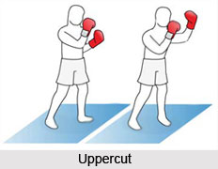 [types of punches boxing - Bing images](https://www.bing.com/images/search?view=detailV2&ccid=5%2BgzqdPu&id=7950CBAE45E3520A61D445320F7898CC1E375C4D&thid=OIP.5-gzqdPuExR3lDqdcqFQuQAAAA&mediaurl=https%3A%2F%2Fwww.indianetzone.com%2Fphotos_gallery%2F93%2FUppercut_Kickboxing_Technique_1.jpg&exph=180&expw=232&q=types+of+punches+boxing&simid=607990073488249532&form=IRPRST&ck=0D3C189E177DA83A14F4B4FBAFC6D744&selectedindex=5&ajaxhist=0&ajaxserp=0&pivotparams=insightsToken%3Dccid_KUz7mAw5*cp_A14173F3944ADA01757041E44E4B6508*mid_98EDFE17A6B6D863FEEDEC1F56F78B80F78BCC55*simid_608043236443322812*thid_OIP.KUz7mAw5k-k3mZWlVkp8zQAAAA&vt=0&sim=11&iss=VSI&cdnurl=https%3A%2F%2Fth.bing.com%2Fth%2Fid%2FR.e7e833a9d3ee131477943a9d72a150b9%3Frik%3DTVw3HsyYeA8yRQ%26pid%3DImgRaw%26r%3D0)

UPPERCUT

[Jab punch gnp - Bing images](https://www.bing.com/images/search?view=detailV2&ccid=jEU8QrIv&id=550F4E46046ED33A9B568E488010B62C73B5C4C1&thid=OIP.jEU8QrIvMf-TvyTyJQTQPgHaDS&mediaurl=https%3A%2F%2Fi1.wp.com%2Fulasku.com%2Fwp-content%2Fuploads%2F2020%2F09%2Fpunch.png%3Fresize%3D679%252C301%26ssl%3D1&exph=301&expw=679&q=Jab+punch+gnp&simid=608031794621598877&form=IRPRST&ck=2C9BAA388201A9C6C1CA5AC1F33E9D2B&selectedindex=61&ajaxhist=0&ajaxserp=0&vt=0&sim=11&cdnurl=https%3A%2F%2Fth.bing.com%2Fth%2Fid%2FR.8c453c42b22f31ff93bf24f22504d03e%3Frik%3DwcS1cyy2EIBIjg%26pid%3DImgRaw%26r%3D0)

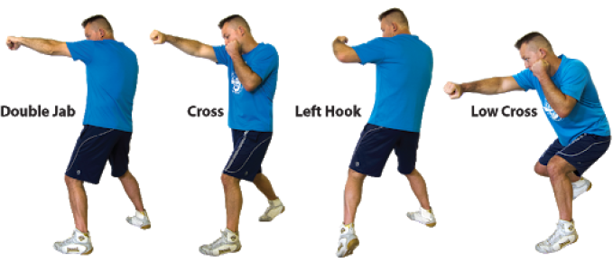

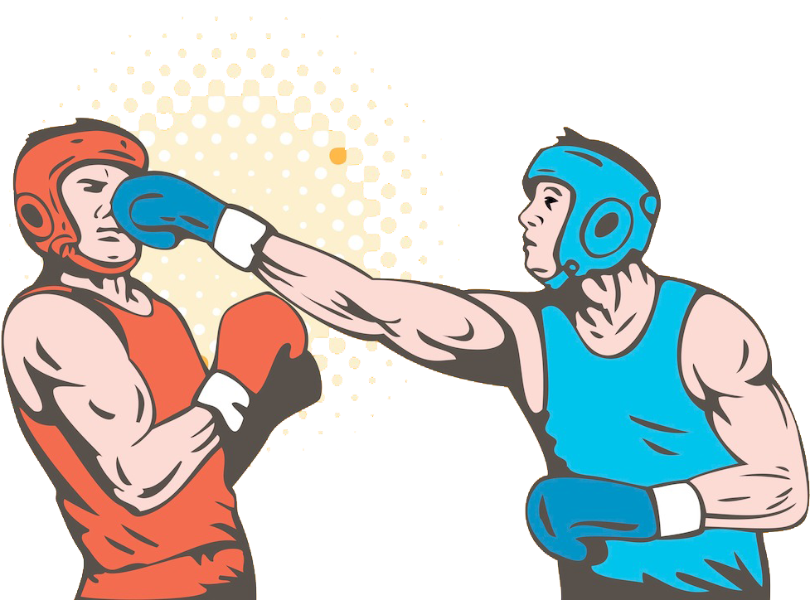

[box Cross Punch png - Bing images](https://www.bing.com/images/search?view=detailV2&ccid=a12u0Fb5&id=267203E54CFEA683760BBA5D36732FFF510BB269&thid=OIP.a12u0Fb5SwVbCS7S7PqOBAHaFf&mediaurl=https%3a%2f%2fwww.pinclipart.com%2fpicdir%2fbig%2f6-63074_yearbook-clipart.png&cdnurl=https%3a%2f%2fth.bing.com%2fth%2fid%2fR.6b5daed056f94b055b092ed2ecfa8e04%3frik%3dabILUf8vczZdug%26pid%3dImgRaw%26r%3d0&exph=724&expw=977&q=box+Cross+Punch+png&simid=607990266774560212&FORM=IRPRST&ck=DE3E4C45F6CCB61391DDA51F88254C9C&selectedIndex=10&ajaxhist=0&ajaxserp=0)

[imgurl:https://cdn.iconscout.com/icon/premium/png-256-thumb/boxing-glove-512624.png?f=webp&w=256 - Bing](https://www.bing.com/images/search?view=detailv2&form=SBIHVR&iss=sbi&q=imgurl:https%3A%2F%2Fcdn.iconscout.com%2Ficon%2Fpremium%2Fpng-256-thumb%2Fboxing-glove-512624.png%3Ff%3Dwebp%26w%3D256&pageurl=https%3A%2F%2Ficonscout.com%2Ficon%2Fboxing-glove&pagetl=Boxing+glove+Icon+-+Download+in+Colored+Outline+Style&imgalt=Boxing+glove+Icon&imgsz=256x256&selectedindex=0&id=https%3A%2F%2Fcdn.iconscout.com%2Ficon%2Fpremium%2Fpng-256-thumb%2Fboxing-glove-512624.png%3Ff%3Dwebp%26w%3D256&ccid=XjXN4vNa&mediaurl=https%3A%2F%2Fcdn.iconscout.com%2Ficon%2Fpremium%2Fpng-256-thumb%2Fboxing-glove-512624.png%3Ff%3Dwebp%26w%3D256&exph=256&expw=256&vt=4)

[Jab Jab Cross png - Bing images](https://www.bing.com/images/search?view=detailV2&ccid=bWKe8uwX&id=743FFDD99ABEDCA59D607EFF14297A6FF541832E&thid=OIP.bWKe8uwXkpVKAna7J9YAMAAAAA&mediaurl=https%3A%2F%2Fcdn2.iconfinder.com%2Fdata%2Ficons%2Fboxing%2F500%2FBoxing_17-256.png&cdnurl=https%3A%2F%2Fth.bing.com%2Fth%2Fid%2FR.6d629ef2ec1792954a0276bb27d60030%3Frik%3DLoNB9W96KRT%252ffg%26pid%3DImgRaw%26r%3D0&exph=256&expw=256&q=Jab+Jab+Cross+png&simid=608054510722491138&form=IRPRST&ck=BBE5CBFB10DAED74027BBEF5F6C258EC&selectedindex=8&ajaxhist=0&ajaxserp=0&vt=0&sim=11)

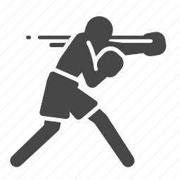

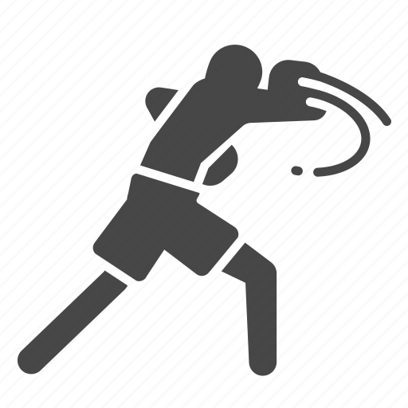

[Boxer, boxing, fighter, hit, hook, punch, boxing traing icon - Download on Iconfinder](https://www.iconfinder.com/icons/1134301/boxer_boxing_fighter_hit_hook_punch_boxing_traing_icon)

[Jab Jab Cross png - Bing images](https://www.bing.com/images/search?view=detailV2&ccid=qPGpIKGP&id=FC750BA59333F365A3C53FDE9A1BC66E3F012194&thid=OIP.qPGpIKGPxyx2KeU17mGWOQAAAA&mediaurl=https%3A%2F%2Fcdn2.iconfinder.com%2Fdata%2Ficons%2Fboxing%2F500%2FBoxing_15-256.png&cdnurl=https%3A%2F%2Fth.bing.com%2Fth%2Fid%2FR.a8f1a920a18fc72c7629e535ee619639%3Frik%3DlCEBP27GG5rePw%26pid%3DImgRaw%26r%3D0&exph=256&expw=256&q=Jab+Jab+Cross+png&simid=608027147487028184&form=IRPRST&ck=85577A5426C9A9596F90AF67B3ED3E75&selectedindex=0&ajaxhist=0&ajaxserp=0&vt=0&sim=11&pivotparams=insightsToken%3Dccid_bWKe8uwX*cp_BBE5CBFB10DAED74027BBEF5F6C258EC*mid_743FFDD99ABEDCA59D607EFF14297A6FF541832E*simid_608054510722491138*thid_OIP.bWKe8uwXkpVKAna7J9YAMAAAAA&iss=VSI&ajaxhist=0&ajaxserp=0)

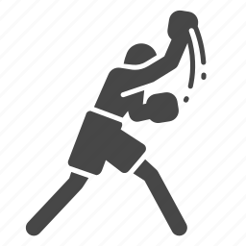

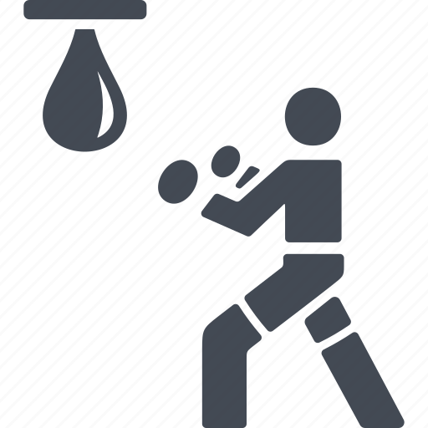 [Hook Punch PNG - Bing images](https://www.bing.com/images/search?view=detailV2&ccid=i2PRF2PJ&id=EE14E2E8BABBE1E57AEDB9ACCBBA2774D4081818&thid=OIP.i2PRF2PJ_WSvsq3w22Xr4wHaHa&mediaurl=https%3A%2F%2Fcdn3.iconfinder.com%2Fdata%2Ficons%2Fboxing-2%2F92%2Ficon107-11-512.png&cdnurl=https%3A%2F%2Fth.bing.com%2Fth%2Fid%2FR.8b63d11763c9fd64afb2adf0db65ebe3%3Frik%3DGBgI1HQnususuQ%26pid%3DImgRaw%26r%3D0&exph=512&expw=512&q=Hook+Punch+PNG&simid=608036021045652464&form=IRPRST&ck=A3D85288A000C7B4B3286883E894309B&selectedindex=6&ajaxhist=0&ajaxserp=0&pivotparams=insightsToken%3Dccid_SH47QfCC*cp_1D5283B6950239EE9DCABE8ED5BEB85B*mid_18786C82B4CB5275048B6C40D72C726E3BCE29FE*simid_608044366182488909*thid_OIP.SH47QfCCI6ELIP7bMV2bDQHaHa&vt=0&sim=11&iss=VSI&ajaxhist=0&ajaxserp=0)

 [Boxer, boxing, fight, fighting, gloves, punch icon - Download on Iconfinder](https://www.iconfinder.com/icons/1494292/boxer_boxing_fight_fighting_gloves_punch_icon)

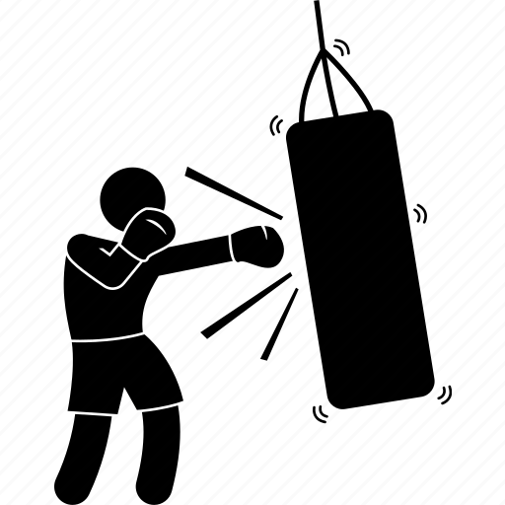

[BOX PUNCHES PNG - Bing images](https://www.bing.com/images/search?view=detailV2&ccid=u2iF%2bLBA&id=C05600D30C20309D9A40FB89BBABAC0460F00EE2&thid=OIP.u2iF-LBAZJDnuzay_rZziwHaHa&mediaurl=https%3a%2f%2fcdn3.iconfinder.com%2fdata%2ficons%2fboxing-boxer%2f386%2fkick-boxer-012-512.png&cdnurl=https%3a%2f%2fth.bing.com%2fth%2fid%2fR.bb6885f8b0406490e7bb36b2feb6738b%3frik%3d4g7wYASsq7uJ%252bw%26pid%3dImgRaw%26r%3d0&exph=512&expw=512&q=BOX+PUNCHES+PNG&simid=608042162681695359&FORM=IRPRST&ck=0732AF37B2D2E824AE4634975ABF0D8E&selectedIndex=5&ajaxhist=0&ajaxserp=0)